REPORT
21.04.25

Vynokur Artur
4CS-23

1) Sum of Sales Amount and Sales Amount by Due Date by Fiscal Year

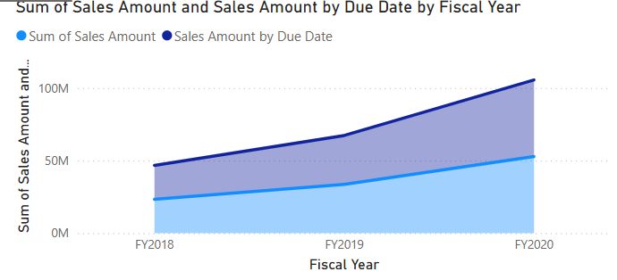
This is a line graph that displays the cumulative amount of sales (Sum of Sales Amount) over time, broken down by Fiscal Year.
The X-axis is horizontal: Fiscal years - FY2018, FY2019, FY2020.
Y-axis (vertical): Sum of Sales Amount in millions of dollars (0M, 50M, 100M).

Light blue area (Sum of Sales Amount): Shows the cumulative sales amount for the entire period for all data.
Dark blue line (Sales Amount by Due Date): Displays the amount of sales broken down by Due Date within the fiscal years.

2)Sum of Sales Amount by Category and Fiscal Year

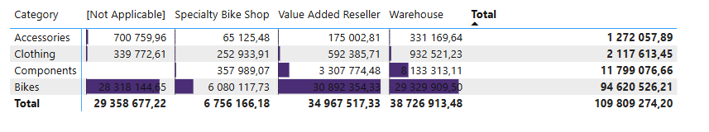
This is a matrix that displays the dollar amount of sales, broken down by:
Product Categories: Accessories, Clothing, Components, Bikes.
Reseller Business Type: , Specialty Bike Shop, Value Added Reseller, Warehouse.
Total amount (TOTAL): Total sales for each category and for all categories together.

The largest category:
The Bikes category has the largest sales volume at $109,133,225.76, which is approximately 99.4% of the total ($109,809,274.20). This confirms that bicycles are the main source of revenue.
The smallest category:
The Accessories category has the lowest sales volume at $1,272,057.89, which is only 1.16% of the total.
Breakdown by reseller type:
Warehouse resellers have the largest sales volume - $38,726,913.48, which is 35.3% of the total.
Specialty Bike Shop has the lowest sales volume among resellers - $6,756,166.18, or 6.15%.
Value Added Reseller has a significant sales volume of $34,967,517.33, or 31.8%.
NOT APPLICABLE (Direct sales) also have a significant volume - $29,358,677.22, or 26.7%.

3) Sum of Sales Amount by Year
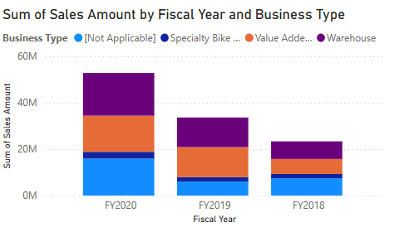
This is a line graph that displays the total amount of sales (Sum of Sales Amount) by calendar year.
The X-axis is horizontal: Years - 2017, 2018, 2019, 2020.
Y-axis (vertical): Sum of Sales Amount in millions (0M, 10M, 20M, 30M, 40M).
Line: Shows the change in the total sales amount during the indicated years.

Sales trend:
In 2017, the sales amount was just over 10M.
In 2018, there was an increase to about 20M.
In 2019, sales reached a peak of about 40M, which is the highest value for the entire period.
In 2020, the sales amount decreased to about 30M.
Dynamics:
From 2017 to 2019, there was a steady increase in sales, with the biggest jump between 2018 and 2019.
In 2020, sales declined, which may indicate external factors such as the economic situation, the COVID-19 pandemic (which began in 2020), or changes in supply or demand.

4) Sum of Sales Amount by Year

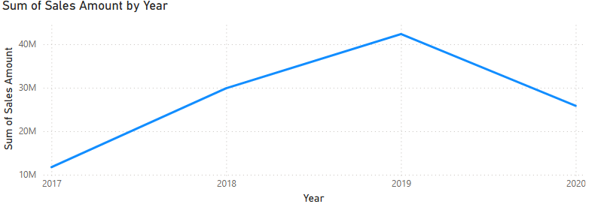

A Line Chart is a graph used to show how data changes over time.
Line charts are typically used to show trends and dynamics, which makes them ideal for analyzing sales over time.

In 2017, the sales amount was just above 10M.
In 2018, it increased to about 20M.
In 2019, sales peaked at around 40M.
In 2020, the sales amount decreased to about 30M.
Trend: There was an increase from 2017 to 2019 with a peak in 2019, after which sales declined in 2020.

Additional information

First, I created a hierarchy for the following subgroups,

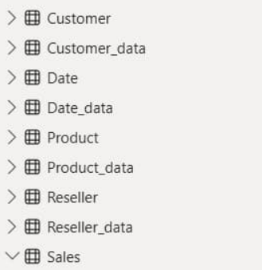
then I replaced the formula (Measure ==) to the: Sales Amount by Due Date = CALCULATE(SUM(Sales[Sales Amount]),USERELATIONSHIP(Sales[DueDateKey],'Date'[DateKey])).
This allowed me to make the graphs and visualizations I described above.
I also created bookmarks for switching graphs, dynamic switching between pages using buttons, and a mobile version.
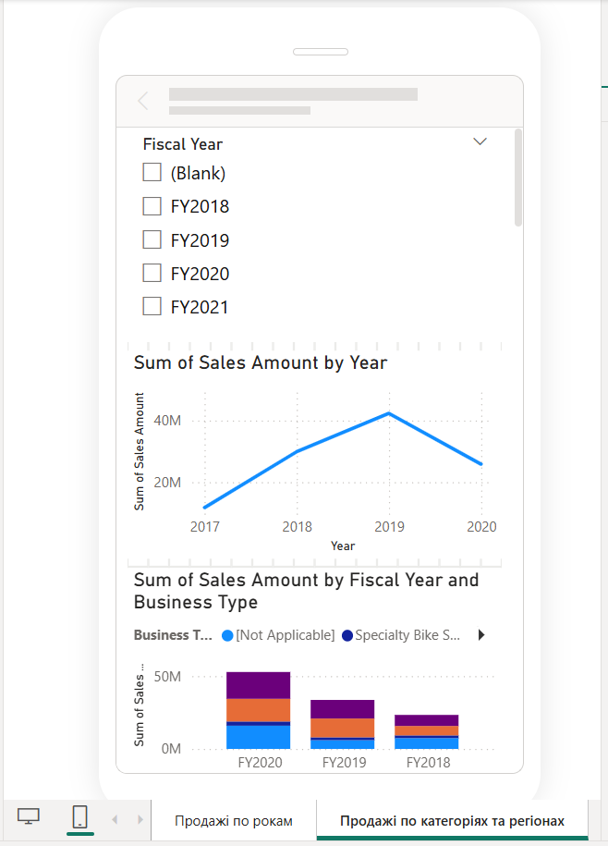

I created two buttons: Graph and Table and Map, but they do not work very well for me.

